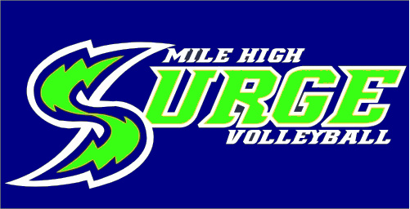

Mile High Surge
Try Out Checklist

__________Information Sheet

__________Covid-19 Waiver

__________RMR Spectator Code of Conduct

__________Copy of Birth Certificate/Passport

__________$20 Try Out Fee – Non-Refundable

__________RMR Membership Card

